INDEX
Quick links; Boilerplate description,
press releases ………………………………… Page 1
Asteroid Day 2019 Press Release……………… Page 2
Asteroid Day 2019 Events in Luxembourg…… Page 3
Asteroid Day LIVE 2019 Participants…………. Page 4
100x Declaration……………………………….. Page 5
Key Messages & Asteroid Facts……………….. Page 5
UN Declaration of Asteroid Day………………. Page 6
Role of Luxembourg…………………………… Page 7
Prime Sponsors…………………………………. Page 8
Quotes by Asteroid Day Supporters……………. Page 10

QUICK LINKS

Website: AsteroidDay.org
Asteroid Day Events: http://www.AsteroidDay.org/events (note 2018)
Asteroid Day LIVE: AsteroidDay.org/live (note 2018)
Media Resources:: https://archive.asteroidday.org/newsroom/
Photos:: https://drive.google.com/open?id=0B26qPfEwFxyCaXV0MURZMHJ5Qk0
Video: https://drive.google.com/drive/u/2/folders/0B26qPfEwFxyCdDZINXgyQ21EUUE

OFFICIAL BOILERPLATE DESCRIPTION

Asteroid Day was co-founded in 2014, by Dr. Brian May, astrophysicist and lead guitarist for the rock band QUEEN, Danica Remy, B612 President, Apollo astronaut Rusty Schweickart, and filmmaker Grig Richters. Asteroid Day is held on 30 June each year to mark the date of Earth’s largest asteroid impact in recorded history, the Siberia Tunguska event. In 2016, with the support and leadership of the Association of Space Explorers (ASE), the United Nations declared Asteroid Day to be a global day of education to raise awareness and promote knowledge in the general public about asteroids. Major events in past years have taken place in London, San Francisco, Washington, DC, Tanzania, Milan and Rimini, Italy, Garching, Germany, Santiago, Chile, and Rio de Janiero, Brazil, in addition to thousands of events worldwide.

Major sponsors of Asteroid Day include the Luxembourg Space Agency, B612, Broadcasting Centre Europe (BCE), OHB, SES, and Tomorrow Street, a joint venture of Vodaphone and Technoport. Asteroid Day global programs, including Asteroid Day LIVE, are programs of the Asteroid Foundation, a Luxembourg-based nonprofit organization.

PRESS RELEASE: 15 February, 2019

ASTEROID DAY TO CELEBRATE FIFTH ANNIVERSARY WITH SPECIAL EVENTS IN LUXEMBOURG AND AROUND THE GLOBE, 24-30 JUNE, 2019

LUXEMBOURG (15 February 2019) -- Asteroid Day, the official United Nations’ day of global awareness and education about asteroids, will celebrate its fifth anniversary on 30 June. What began as two live stream broadcasts in 2014, now includes thousands of independent events organized by citizens around the world on all five continents. Asteroid Day global programs, including Asteroid Day LIVE, are programs of the Asteroid Foundation, a Luxembourg-based nonprofit organization.

Asteroid Day was co-founded by astrophysicist and famed musician Dr. Brian May of the rock group QUEEN; Apollo 9 Astronaut Rusty Schweickart; Filmmaker Grig Richters; and B612 President Danica Remy, to promote awareness and provide knowledge to the general public about the importance of asteroids in the formation of our universe and the role they play in our solar system today. Events are scheduled during the week of 30 June, the date of the largest asteroid impact of Earth in recorded history (Tunguska).

In just five years, Asteroid Day has evolved to include the participation of all major national space agencies, ESA, JAXA, Roscosmos, and NASA, and prominent scientists, astronomers, educators and media worldwide. In 2016, the United Nations declared Asteroid Day an official day of education, initiated in part by a need to better understand the role of asteroids, following the 15 February, 2013 meteor impact in Chelyabinsk, Russia.

“Our goal is to dedicate one day each year to learn about asteroids, the origins of our universe, and to support the resources necessary to find asteroids,” explains Dr. May.

A principal partner in Asteroid Day is the Government of the Grand Duchy of Luxembourg through the Luxembourg Space Agency, which is leading the SpaceResources.lu initiative. “By establishing itself as the European Hub in the future space resources economy, Luxembourg is committed to supporting and nurturing the growing commercial space industry and contributing to the peaceful exploration and sustainable utilization of resources from celestial bodies, including the Moon or near-earth objects such as asteroids,” stated Etienne Schneider, Deputy Prime Minister and Minister of the Economy of Luxembourg. “Asteroid Day supports the goals of the SpaceResources.lu initiative by educating the world about asteroids, space missions and what’s possible within the emerging New Space economy.”

Events for Asteroid Day 2019 will take place on all seven continents and are in the process of being organized by local organizations, and include:

● In Europe: Luxembourg’s Ministry of Education, SpaceResources.lu and National Museum of Natural History are organizing events throughout the country. The Natural History Museum Vienna, Austria, will showcase the world’s largest meteorite collection. In Greece, the new Hellenic Meteorite Museum is hosting a variety of events.
● In North America: Events will be held once again at the Smithsonian’s National Air and Space Museum in Washington, DC, the Perot Museum of Nature and Science in Dallas, Texas, in addition to other science centers, universities and astronomy clubs throughout the US, Canada and Mexico.
● In South America: A group of astronomical backpackers called Mochileros Astronomicos, will hitchhike throughout the region to teach astronomy in schools, planetariums, and communities. Astronomical institutions across Brazil will discuss asteroids at events celebrating 100 years of the International Astronomical Union. Chile will have coordinated activities across the country.
● In Africa: Mozambique will host a special presentation about asteroids on National TV (TVM), in coordination with the International Astronomical Union (IAU), at a special session during the National Astronomical Society Meeting. Egypt’s Scientific Society of Astronomy and Space will hold an event called "Asteroids and Safety of The Earth" at the National Research Institute of Astronomy and Geophysics in Cairo.
● In Asia: Kazakhstan Fesenkov Astrophysical Institute, in Almaty will host lectures and activities for students. Throughout Israel, events are being organized at the Givatayim Observatory, Netanya Planetarium and the Yarqa Space Center.

Themes of Asteroid Day 2019 range from the science of asteroids in the formation of our solar system to discussions of new space industries accelerating technologies to advance space-based activities. Activities will importantly also highlight the current missions advancing efforts to identify the characteristics and trajectories of asteroids and develop greater detection, tracking and deflection techniques: DART, the first demonstration of a kinetic impact technique to change the motion of an asteroid in space.; (NASA/ESA); and two study and sample return missions: Hayabusa 2, (JAXA); and OSIRIX REx (NASA).

Preview of 2019 ASTEROID DAY Events in Luxembourg
Information for public participation at the AsteroidDay.org website

● 27 June: Technical Briefing with Asteroid Experts (by invitation)
● 28 June: Asteroid Day LIVE Global Broadcast-Webcast, produced at RTL Studios
● 29 June: Astronaut and Asteroid Expert meet and greet (public)
● 29 June: Gala Dinner in the unique Cercle Cité, Downtown Luxembourg (tickets on sale)
● 30 June: Asteroid Day at the National Museum of Natural History: Guided tours of the Meteorite Collection and “Universe” Exhibition; Public Lecture “Asteroids… can we deal with the danger?”; Asteroid Workshop for Youth

ASTEROID DAY LIVE FROM LUXEMBOURG: 28 JUNE, 2019

Asteroid Day LIVE, which debuted in 2017 and expanded last year to 48 hours of live programming, is the first-ever global conversation about asteroids. It is produced by the Asteroid Foundation and broadcast live from the Broadcasting Center Europe (BCE) studio at RTL City in Luxembourg. Asteroid Day LIVE returns in 2019, with an expanded five days of online, broadcast and webcast content and commentary from international experts, five astronauts/cosmonauts, scientists, physicists, educators, and government officials and special guests who serve as Asteroid Day ambassadors. This year will also include five Luxembourg-based space startup companies and five featured global independently organized Asteroid Day events from five different countries.

Participants in Asteroid Day LIVE 2019 (announced to date):

- Johann-Dietrich Wörner, Director General, ESA
- Etienne Schneider, Deputy Prime Minister, and Minister of the Economy, Govt. of Luxembourg
- Marc Serres, CEO, Luxembourg Space Agency
- Simonetta Di Pippo, Director, United Nations Office of Peaceful Uses of Outer Space
- Georges Schmit, Special Envoy for Space Resources, Govt. of Luxembourg; Asteroid Foundation Chair
- Rusty Schweickart, Apollo 9 Astronaut; Asteroid Day Co-founder
- Ed Lu, Executive Director, Asteroid Institute; three-time NASA astronaut (STS 84, 106 and ISS Expedition 7); Asteroid Day Expert Panel
- Nicole Stott, Mission Specialist (STS 128, 133 and ISS Expeditions 20, 21); Astronaut Artist
- Dorin Prunariu, first and only Romanian cosmonaut; Asteroid Day Ambassador
- Alexander Misurkin, Cosmonaut, ISS Commander 2018, Russia
- Danica Remy, President, B612 Foundation; Asteroid Day Co-founder
- Simon (Pete) Worden, President, Breakthrough Institute; former Director, NASA Ames Research Center
- Frans Van Der Donck, Space Policy Expert, The Netherlands
- Ian Carnelli, Project Manager, Hera mission (kinetic impactor validation), ESA
- Mark Boslough, Physicist, Sandia National Labs (ret.); Chair, Asteroid Day Expert Panel
- Lynne Jones, Co-Chair, LSST Solar System Science Collaboration; Asteroid Day Expert Panel
- Robert Jedicke, University of Hawaii, US, Institute for Astronomy; Asteroid Day Expert Panel
- Patrick Michel, Senior Researcher, CNRS, Lagrange laboratory of Observatoire de la Côte d’Azur; Co-I of Hayabusa2 and OSIRIS-Rex; lead scientist, ESA Hera mission, France; Asteroid Day Expert Panel

Asteroid Day LIVE from Luxembourg will be distributed via a dedicated satellite, available on local channels subscribing to the SES satellite network, and via the Asteroid Day website. For archived programs of 2017 and 2018, see: www.youtube.com/user/asteroidday/featured

Scientists Rock is a seven-part series about asteroids produced by Asteroid Day, which can be viewed on website. Narrated by famed astrophysicist Neil deGrasse Tyson, the series includes interviews with UK Astronomer Royal Lord Martin Rees, Dr. Brian May, Peter Gabriel, and scores of astronauts and asteroid experts.

About Asteroid Day:
Asteroid Day was co-founded in 2014, by Dr. Brian May, astrophysicist and lead guitarist for the rock band QUEEN, Danica Remy, B612 President, Apollo astronaut Rusty Schweickart, and filmmaker Grig Richters. Asteroid Day is held on 30 June each year to mark the date of Earth’s largest asteroid impact in recorded history, the Siberia Tunguska event. In 2016, with the support and leadership of the Association of Space Explorers (ASE), the United Nations declared Asteroid Day to be a global day of education to raise awareness and promote knowledge in the general public about asteroids. Major events in past years have taken place in London, San Francisco, Washington, DC, Tanzania, Milan and Rimini, Italy, Garching, Germany, Santiago, Chile, and Rio de Janiero, Brazil, in addition to thousands of events worldwide.

Major sponsors of Asteroid Day include the Luxembourg Space Agency, B612, Broadcasting Centre Europe (BCE), OHB, SES, and Tomorrow Street, a joint venture of Vodaphone and Technoport. Asteroid Day global programs, including Asteroid Day LIVE, are programs of the Asteroid Foundation, a Luxembourg-based nonprofit organization.

Join in the Asteroid Day conversation on Social Media!
- Website: AsteroidDay.org
- Twitter: @asteroidday #AsteroidDay2019, #AsteroidDayLive;
- Facebook: www.facebook.com/AsteroidDay #AsteroidDay2019, #AsteroidDayLive
- YouTube: www.youtube.com/user/asteroidday

A Media Kit, including press releases, media alerts, quotes, photos, video, and BROLL, is available in the Asteroid Day Newsroom.

100X DECLARATION
A declaration calling for a 100 times increase in the awareness and tracking of asteroids. To date, they have been joined by more than 17,000 world citizens.

Signers of the 100X Declaration number more than 200 leaders in Business, Aerospace, Science and government, and more than 5000 concerned citizens.
- Science: Richard Dawkins, Jane Luu, Helen Sharman, Jill Tarter, Brian Cox, Lord Martin Rees, Astronomer Royal of the UK and the late Stephen Hawking
- Astronauts: Tom Jones, Chris Hadfield, Ed Lu
- Entertainment: Terry Gilliam, Stephen Fry, Peter Gabriel, Brian May, Broken Bells, Will Wright, David Braben
- Business: David Liddle, Shervin Pishevar, Steve Jurvetson, Jeffrey Baehr, Anousheh Ansari, Alan Eustace, Chris Anderson, Sasha Galitsky

For a full listing of signers of the 100X Declaration, visit: https://asteroidday.org/about/our-team/#hash_filters=100x-declaration-signatories

KEY MESSAGES

What is Asteroid Day?
- Asteroid Day is a UN sanctioned global day of education to raise awareness about asteroids
- Asteroid Day is held each year on June 30, the anniversary of the largest asteroid impact of Earth in recent history (Tunguska, Siberia, June 30, 1908)
- Asteroid Day reminds us that we are citizens of our Universe [crew of Spaceship Earth] and stewards of our Planet and it is our responsibility to learn about asteroids.

Asteroid Facts
- Asteroids are rocky objects, left over from the formation of planets in our solar system. Like planets, asteroids orbit the Sun, but most are contained in the Asteroid Belt between Mars and Jupiter.
- We need to accelerate the rate of asteroid discovery by funding space telescopes and other tools and technologies to find asteroids.
- Asteroids can pose a risk to the earth, although the threat is low in any one year, the consequences can be serious. There three million or so asteroids we haven’t identified which could pose threat.
- We have the technological capability to detect and track and deflect ones away from impacting Earth.

Who Supports Asteroid Day?
- Asteroid Day is supported by international organizations, government agencies, local communities and leaders in science, technology, education, business and entertainment.
- Major sponsors of Asteroid Day 2019 include the Government of Luxembourg, B612 Foundation, Broadcasting Centre Europe (BCE), SES, OHB and Tomorrow Street, a joint venture of Vodaphone and Technoport. Asteroid Day is a program of the Asteroid Foundation, a Luxembourg-based nonprofit organization.
- Media partners: Discovery Communications, Astronomy Magazine

Who attends Asteroid Day events and where?
- What makes Asteroid Day so successful are the volunteers and hosts of global events held around the world in more than 190 countries. To date we have 125 regional coordinators across the globe.
- Participants in Asteroid Day include people of all ages, from scientists, technologists, community leaders to students - anyone interested in learning about asteroids and helping to protect our planet from dangerous impacts.
- Our goal for June 30, 2019 is 2000 self-organized educational events held on all seven continents.
- In 2019, Asteroid Day will hold a five day broadcast from Luxembourg:

What is Asteroid Day LIVE and How Can I Watch?
From 26-30 June, asteroids are the focus of a conversation shared around the world on the global Asteroid Day Live broadcast about space and the role of asteroids in our solar system. Asteroid Day LIVE, produced by the Asteroid Foundation and sponsored by OHB, BCE and the Government of Luxembourg, will be distributed around the world via a dedicated SES satellite network. The programming will feature prominent scientists, asteroid experts, famed astronauts, technologists, government space leaders, and researchers in planetary science.

ASTEROID DAY IS A UNITED NATIONS OFFICIAL DAY OF EDUCATION AND AWARENESS ABOUT PLANETARY SCIENCE

How does the United Nations Support Asteroid Day?

In 2016, the United Nations General Assembly recognized Asteroid Day as an official UN event and declared it to be held internationally each year on June 30, the anniversary of the largest asteroid impact in recent history, the 1908 Tunguska impact. The UN resolution invites all United Nations Member States, organizations of the United Nations system, other international and regional organizations, as well as civil society, including non-governmental organizations and individuals to observe Asteroid Day.

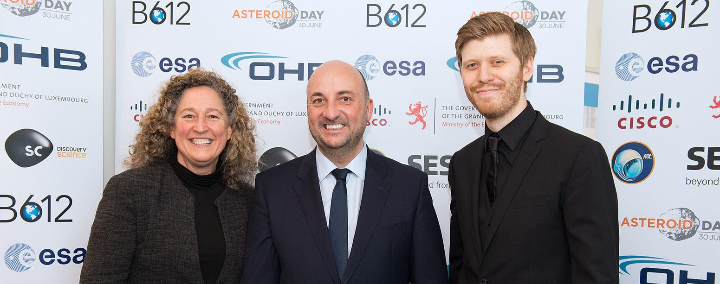
Asteroid Day 2017: Danica Remy,Etienne Schneider and Grig Richters (from left to right). Photo by: Max Alexander

ROLE OF THE LUXEMBOURG GOVERNMENT

Etienne Schneider, Deputy Prime Minister and Minister of the Economy of Luxembourg, has explained his country’s “leading role related to asteroids, within the framework of the SpaceResources.lu initiative. Luxembourg aims to contribute to the peaceful exploration and sustainable utilization of resources from celestial bodies. While asteroids might be seen as a threat to our planet, they are a tremendous opportunity. Indeed, the use of space resources, both on earth and in space, holds great potential for future technological innovation, economic activity and growth with a promise of ecological and social benefits for humanity. To ensure that this vision becomes a reality, we have to increase our knowledge and understanding of asteroids and Near Earth Objects.”

PRINCIPAL ASTEROID DAY SPONSORS

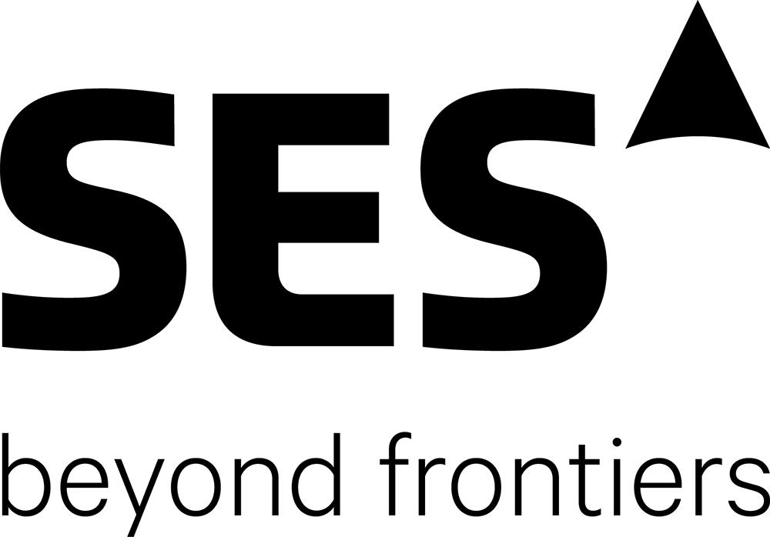
SES is the world’s leading satellite operator and the first to deliver a differentiated and scalable GEO-MEO offering worldwide, with more than 50 satellites in Geostationary Earth Orbit (GEO) and 12 in Medium Earth Orbit (MEO). SES focuses on value-added, end-to-end solutions in two key business units: SES Video and SES Networks. The company provides satellite communications services to broadcasters, content and internet service providers, mobile and fixed network operators, governments and institutions. SES’s portfolio includes the ASTRA satellite system, which has the largest Direct-to-Home (DTH) television reach in Europe, O3b Networks, a global managed data communications service provider, and MX1, a leading media service provider that offers a full suite of innovative digital video and media services. Further information available at: www.ses.com
Quote from Ruy Pinto, SES Deputy Chief Technology Officer:
“At SES, we value technology as a tool to improve and save lives. We are proud to sponsor this global awareness campaign that will bring collaboration where people from around the world come together to learn about asteroids, the impact hazard they may pose, the resources they may one day yield and what we can do to ensure we have the best technology available to protect our planet.”
BCE is a European leader in media services, system integration and software development in the areas of television, radio, production and postproduction, telecommunication and IT. With its extensive experience on the media market, our team provides high-quality services and will always find the solution that matches your project and budget. With more than 200 highly qualified and motivated personnel, BCE serves about 400 clients in various sectors, such as TV channels, radio stations, film distributors, producers, advertising companies, telecommunications operators and public services. Further information available at: www.bce.lu
Quote from Tun Van Rijswick, COO at BCE:
“While Asteroid Day focuses mainly in informing the population about asteroid science and future planetary defense, we believe that this information will need to be delivered to the world with the smartest solutions available. Whereas it is through file-based distribution solutions, media, television, radio or satellite, BCE has an extended expertise in media distribution, allowing the best communication before and maybe during or even after any impact.”
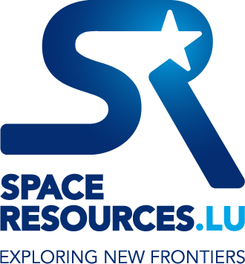
Luxembourg is offering an ideal overall framework for the exploration and commercial utilization of resources from ‘celestial bodies’ such as asteroids or from the moon. By supporting innovative R&D projects in the frame of the SpaceResources.lu initiative, including direct investments in companies active in such advanced space technologies, the Grand Duchy aims to be at the forefront of the next stage of development in the space industry. Space is one of the priority sectors that Luxembourg has constantly promoted since its entry into the space business more than 35 years ago. One of the country’s biggest successes in space was the government-supported SES created in 1985, which is the largest commercial satellite operator in the world today. The SpaceResources.lu initiative is developed and implemented under the political responsibility of the Deputy Prime Minister and Minister of the Economy, Étienne Schneider to position Luxembourg as a European hub for the utilization of space resources. Further information available at: www.spaceresources.public.lu/en
Quote from Étienne Schneider, Luxembourgish Deputy Prime Minister and Minister of the Economy:
“We are very pleased to host the Asteroid Day event in Luxembourg, enhancing the excitement that our SpaceResources.lu initiative is generating across the world,” stated Deputy Prime Minister and Minister of the Economy, Étienne Schneider. “The partnership with the Asteroid Day activities is offering the Grand Duchy an additional opportunity to set its course in the space sector where the country is becoming increasingly important.”

APPROVED ASTEROID DAY QUOTES

Note to Media: All Asteroid Day Expert Panel members are profiled on the Asteroid Day website: http://asteroidday.org/asteroid-day-expert-panel/

Asteroid Day co-founders Brian May (Queen guitarist, astrophysicist), Danica Remy (President of B612), Grig Richters (Filmmaker) and Rusty Schweickart (Apollo 9 astronaut): "Today the United Nations General Assembly has officially declared June 30 as the International Asteroid Day. We founded the annual event to raise awareness of asteroids and opportunity to learn about their role in our solar system. We hope you will join us."

Dr. Brian May, astrophysicist, guitarist and songwriter for QUEEN, Co-Founder, Asteroid Day. “Our goal is to dedicate one day each year to learn about asteroids, the origins of our universe, and to support the resources necessary to see asteroids from Earth’s orbital path.

Ed Lu, three time NASA astronaut and CEO of B612 who co-invented the Gravity Tractor, a proposed technique for asteroid deflection: "The United Nations declaration of Asteroid Day is a testament to the importance of the international work by scientists and engineers around the world to improve our knowledge and detection of asteroids. If we do our job properly, we should have total awareness of the trajectory of all asteroids in the solar system.”

Romanian astronaut Dorin Prunariu: “Asteroid Day is an annual event to inform and educate the general public on asteroids and the activities that are undertaken in connection with asteroids to improve our knowledge. Recognition of this event by the UN General Assembly on the proposal of ASE comes as a natural and necessary consequence that complements other initiatives related to NEO taken by the UN and by other national and international organizations.”

Etienne Schneider, Deputy Prime Minister of Luxembourg: “We are delighted to see the United Nations join in promoting awareness of Asteroids as an opportunity for mankind and for future peaceful exploration.”

Apollo 9 Astronaut Rusty Schweickart: “If we can track the trajectories of asteroids and monitor their movement in our solar system , then we can know if they are on a path to impact Earth,” said “If we find them early enough, we can move them out of Earth’s orbit.”

British astronaut Tim Peake: “All the best for Asteroid Day. We only have one Earth so let’s do all we can to protect it.”

Lord Martin Rees, Astronomer Royal, UK: “The ancients were correct in their belief that the heavens and the motion of astronomical bodies affect life on Earth - just not in the way they imagined. Sometimes those heavenly bodies run into Earth. This is why we must make it our mission to find asteroid..”

French astronaut Jean-François Clervoy
Each asteroid is a natural individual spaceship, unmanned as far as we know. They fly in formation or on their own. Their composition can vary from one to another. They are exciting subjects for many science disciplines such as math, chemistry, biology, geology, cosmology, etc. but also for developing a human interplanetary culture and philosophy. Asteroids invents new shapes, new trajectory curves, new crater geometries. They force us to reflect on our meaning of life. They are potential destinations we can see, touch and visit. They are just cosmic pieces or art which deserve our fascination.

Rakesh Sharma, Research Cosmonaut , India: "While the Moon, Mars and other planets in our solar system are always there, we have many asteroids that pass by the windows of our world while on their celestial wanderings. They are treasure troves of scientific information and we need to intercept, harness and study them with a view to learn about origins of our life and other exotic materials that may be embedded in them. There is much undiscovered and less understood knowledge flying past us, just awaiting our attention."

Canadian Astronaut Chris Hadfield: ‘The Earth gets hit by about 40 tons of small asteroids and their dust each day. But occasionally there is a big one that causes havoc, and we need to do what makes sense, together, to be ready.‘

Tom Jones, Scientist, Author, Pilot and Veteran NASA Astronaut with four Shuttle missions and three spacewalks: “Asteroid Day is a great opportunity to invite the public to learn more about near-Earth asteroids, and to invite their support of international efforts. We study asteroids both to protect the Earth and to protect valuable resources for future exploration toward Mars.”

Dante Lauretta, Professor of Planetary Science, University of Arizona: “Asteroid represents humanity’s growing awareness of the opportunities that exist in near-Earth space. Our future depends on our ability to identify, characterize, and ultimately travel to these asteroids.”

Peter Brown, Professor, University of Western Ontario: “Asteroid Day reminds us we are literally connected with the rest of the Universe. Earth is not an isolated System.”

Mark Boslough, Technologist, Sandia National Labs: “We need to study asteroids because they are scientifically interesting, potential resources, and exciting objects for space exploration.”

Sigrid Close, Assistant Professor of Astronautics, Stanford University: “By studying asteroids, we can understand how hypervelocity objects ablate, ionize and form plasma that then interacts and influences the background atmosphere and ionosphere.”

Eric Christensen, Director, Catalina Sky Survey: “Studying asteroids allows us to look both backward and forward in time; they inform our understanding of the birth and evolution of the Solar System, and potential future impacts present an incentive to catalog and characterize the risk they pose to human populations.”

Patrick Michel, Lead Researcher, CNRS: “Considered the building blocks of our planets, asteroids provide us with tantalizing glimpses of the earliest nature of our solar system. Moreover, asteroid collisions have to be seen as representing an important threat against human efforts in space, which in an extreme case, could even lead to the destruction of our biosphere. Thus, asteroids matter much to scientists, to explorers, and to the future of humanity.”

Christian Koeberl, Cosmochemist, University of Vienna: “Asteroids (and their messenger to Earth, the meteorites) are witnesses of the origin of the solar system and tell us about physical and chemical processes at that time. Asteroid Day helps to educate us about impacts on Earth and elsewhere and their scientific importance.”

Lynne Jones, Research Associate, LSST: “Asteroids are remnants of the planet formation processes in our Solar System and by studying their orbital distribution and chemical composition, we can learn about how planets formed and evolved over the history of the Solar System.

Quotes in Spanish, Hebrew, German, French and Italian
German astronaut Alexander Gerst (German): "Wird ein Asteroid wieder die Erde treffen? Die Frage ist nicht "ob?", sondern "wann?". Eine andere Frage lautet: Werden wir dann in der Lage sein, uns davor zu schützen? Diese Frage kann die Raumfahrt auch beantworten."

Alan Harris, German Aerospace Center (DLR) Senior Scientist and NEOShield Project Coordinator (German): “Aktuell sind erst annähernd 15000 erdnahe Objekte (near-Earth objects: NEO; Asteroiden und Kometen) entdeckt worden und jeden Tag werden circa 4 weitere gefunden. Während wir ungefähr wissen wie viele Objekte pro Größenklasse sich in erdnahen Umlaufbahnen bewegen wissen wir bisher nur sehr wenig über ihre physikalische Eigenschaften, wie ihre Zusammensetzung, ihre Dichte oder Struktur. Befristete Projekte wie NEOShield-2 helfen uns zu verstehen wie wir einen Asteroiden optimal ablenken können aber wir müssen immer noch viel mehr lernen, nicht nur über NEOs im Allgemeinen sondern auch über die technische Machbarkeit von Abwehrmethoden und deren Leistungsfähigkeit. Kurz gesagt: wir brauchen eine langfristige, international koordinierte Strategie zum Schutz der Menschen und zur Abwehr von Einschlägen erdnaher Objekte auf der Erde.”

US astronaut Garrett Reisman and first Jewish crewmember on the ISS (Hebrew):
“שלום ובוקר טוב
אני גארט רייסמן , לשעבר אסטרונאוט בנאסא וחבר הצוות היהודי הראשון על תחנת החלל הבינלאומית .
אני שמח להצטרף אליכם באמצעות ההודעה הזו ואני נרגש מאוד מהתפשטות יום האסטרואיד בעולם ואני ממש שמח שלכולכם בישראל כלכך אכפת מהנושא הזה ואתם מוכנים להתערב ולעזור לנו להגן על הכוכב השברירי שלנו.
האו"ם הכריז זה עתה על ה 30 ביוני כיום האסטרואיד הבינלאומי , יום המודעות לאסטרואידים ולסכנה שהם מהווים לאנושות ולהגנה על כדור הארץ.
זה נהדר שגם ישראל מציינת את היום הזה יחד עם כולנו בכל העולם.
אז הצטרפו אלינו ב 30 ביוני וקחו חלק ביום האסטרואיד בישראל.
שוב שלום ואני מקווה לראות את כולכם בישראל בקרוב מאוד.
ביי ביי

Spanish astronaut Pedro Duque (Spanish): “Todos los astronautas estamos concienciados del riesgo de impacto de la Tierra con asteroides. Por eso nuestra Asociación de Exploradores del espacio apoya decididamente el desarrollo de tecnologías operacionales para poderlos detectar y desviar. Es para mí una gran satisfacción ver como el día de hoy la Asamblea General de las Naciones Unidas ha declarado el 30 de Junio como "Día Internacional del Asteroide", reconociendo el valor del evento anual de concienciación de la sociedad que venimos celebrando desde 2014.”

Italian astronaut Luca Parmitano (Italian): “La minaccia da parte degli asteroidi è un problema internazionale che dovrebbe essere affrontato globalmente, interessando ad ogni livello tutte le nazioni coinvolte nell’avventura spaziale: dalle istituzioni educative ai centri di ricerca e alle agenzie spaziali.”

