ASTEROID DAY TO CELEBRATE FIFTH ANNIVERSARY WITH SPECIAL EVENTS IN LUXEMBOURG AND AROUND THE GLOBE, 24-30 JUNE, 2019

LUXEMBOURG (15 February 2019) -- Asteroid Day, the official United Nations’ day of global awareness and education about asteroids, will celebrate its fifth anniversary on 30 June. What began as two live stream broadcasts in 2014, now includes thousands of independent events organized by citizens around the world on all five continents. Asteroid Day global programs, including Asteroid Day LIVE, are programs of the Asteroid Foundation, a Luxembourg-based nonprofit organization.

Asteroid Day was co-founded by astrophysicist and famed musician Dr. Brian May of the rock group QUEEN; Apollo 9 Astronaut Rusty Schweickart; Filmmaker Grig Richters; and B612 President Danica Remy, to promote awareness and provide knowledge to the general public about the importance of asteroids in the formation of our universe and the role they play in our solar system today. Events are scheduled during the week of 30 June, the date of the largest asteroid impact of Earth in recorded history (Tunguska).

In just five years, Asteroid Day has evolved to include the participation of all major national space agencies, ESA, JAXA, Roscosmos, and NASA, and prominent scientists, astronomers, educators and media worldwide. In 2016, the United Nations declared Asteroid Day an official day of education, initiated in part by a need to better understand the role of asteroids, following the 15 February, 2013 meteor impact in Chelyabinsk, Russia.

“Our goal is to dedicate one day each year to learn about asteroids, the origins of our universe, and to support the resources necessary to find asteroids,” explains Dr. May.

A principal partner in Asteroid Day is the Government of the Grand Duchy of Luxembourg through the Luxembourg Space Agency, which is leading the SpaceResources.lu initiative. “By establishing itself as the European Hub in the future space resources economy, Luxembourg is committed to supporting and nurturing the growing commercial space industry and contributing to the peaceful exploration and sustainable utilization of resources from celestial bodies, including the Moon or near-earth objects such as asteroids,” stated Etienne Schneider, Deputy Prime Minister and Minister of the Economy of Luxembourg. “Asteroid Day supports the goals of the SpaceResources.lu initiative by educating the world about asteroids, space missions and what’s possible within the emerging New Space economy.”

Events for Asteroid Day 2019 will take place on all five continents and are in the process of being organized by local organizations, and include:

- In Europe: Luxembourg’s Ministry of Education, SpaceResources.lu and National Museum of Natural History are organizing events throughout the country. The Natural History Museum Vienna, Austria, will showcase the world’s largest meteorite collection. In Greece, the new Hellenic Meteorite Museum is hosting a variety of events.
- In North America: Events will be held once again at the Smithsonian’s National Air and Space Museum in Washington, DC, the Perot Museum of Nature and Science in Dallas, Texas, in addition to other science centers, universities and astronomy clubs throughout the US, Canada and Mexico.
- In South America: A group of astronomical backpackers called Mochileros Astronomicos, will hitchhike throughout the region to teach astronomy in schools, planetariums, and communities. Astronomical institutions across Brazil will discuss asteroids at events celebrating 100 years of the International Astronomical Union. Chile will have coordinated activities across the country.
- In Africa: Mozambique will host a special presentation about asteroids on National TV (TVM), in coordination with the International Astronomical Union (IAU), at a special session during the National Astronomical Society Meeting. Egypt’s Scientific Society of Astronomy and Space will hold an event called "Asteroids and Safety of The Earth" at the National Research Institute of Astronomy and Geophysics in Cairo.
- In Asia: Kazakhstan Fesenkov Astrophysical Institute, in Almaty will host lectures and activities for students. Throughout Israel, events are being organized at the Givatayim Observatory, Netanya Planetarium and the Yarqa Space Center.

Themes of Asteroid Day 2019 range from the science of asteroids in the formation of our solar system to discussions of new space industries accelerating technologies to advance space-based activities. Activities will importantly also highlight the current missions advancing efforts to identify the characteristics and trajectories of asteroids and develop greater detection, tracking and deflection techniques: DART, the first demonstration of a kinetic impact technique to change the motion of an asteroid in space.; (NASA/ESA); and two study and sample return missions: Hayabusa 2, (JAXA); and OSIRIX REx (NASA).

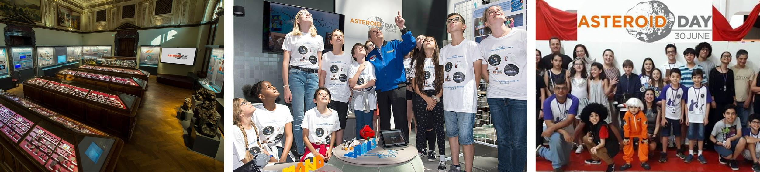

Preview of 2019 ASTEROID DAY Events in Luxembourg
Information for public participation at the AsteroidDay.org website

- 27 June: Technical Briefing with Asteroid Experts (by invitation)
- 28 June: Asteroid Day LIVE Global Broadcast-Webcast, produced at RTL Studios
- 29 June: Astronaut and Asteroid Expert meet and greet (public)
- 29 June: Gala Dinner in the unique Cercle Cité, Downtown Luxembourg (tickets on sale)
- 30 June: Asteroid Day at the National Museum of Natural History: Guided tours of the Meteorite Collection and “Universe” Exhibition; Public Lecture “Asteroids… can we deal with the danger?”; Asteroid Workshop for Youth

ASTEROID DAY LIVE FROM LUXEMBOURG: 28 JUNE, 2019

Asteroid Day LIVE, which debuted in 2017 and expanded last year to 48 hours of live programming, is the first-ever global conversation about asteroids. It is produced by the Asteroid Foundation and broadcast live from the Broadcasting Center Europe (BCE) studio at RTL City in Luxembourg. Asteroid Day LIVE returns in 2019, with an expanded five days of online, broadcast and webcast content and commentary from international experts, five astronauts/cosmonauts, scientists, physicists, educators, and government officials and special guests who serve as Asteroid Day ambassadors. This year will also include five Luxembourg-based space startup companies and five featured global independently organized Asteroid Day events from five different countries.

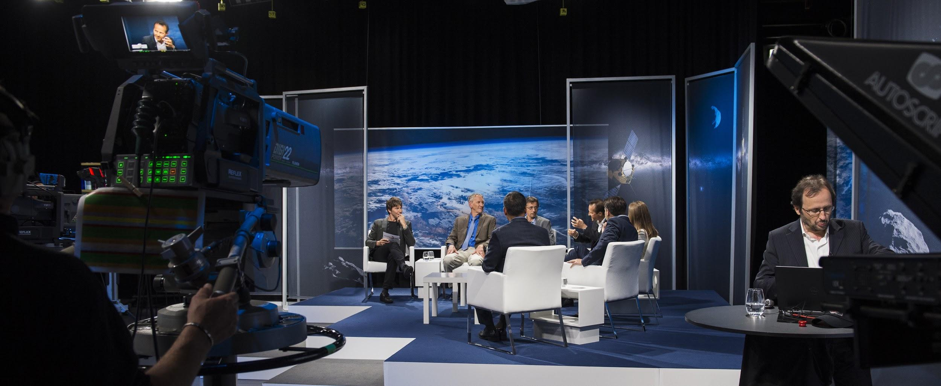

Participants in Asteroid Day LIVE 2019 (announced to date):
- Johann-Dietrich Wörner, Director General, ESA
- Etienne Schneider, Deputy Prime Minister, and Minister of the Economy, Government of Luxembourg
- Marc Serres, CEO, Luxembourg Space Agency
- Simonetta Di Pippo, Director, United Nations Office of Peaceful Uses of Outer Space
- Georges Schmit, Special Envoy for Space Resources, Government of Luxembourg; Asteroid Foundation Chair
- Rusty Schweickart, Apollo 9 Astronaut; Asteroid Day Co-founder
- Ed Lu, Asteroid Day Expert Panel; Executive Director, Asteroid Institute; three-time NASA astronaut (STS 84, 106 and ISS Expedition 7).
- Nicole Stott, Mission Specialist (STS 128, 133 and ISS Expeditions 20, 21); Astronaut Artist
- Dorin Prunariu, first and only Romanian cosmonaut; Asteroid Day Ambassador
- Alexander Misurkin, Cosmonaut, ISS Commander 2018, Russia
- Danica Remy, President, B612 Foundation; Asteroid Day Co-founder
- Simon (Pete) Worden, President, Breakthrough Institute; former Director, NASA Ames Research Center
- Frans Van Der Donck, Space Policy Expert, The Netherlands
- Ian Carnelli, Project Manager, Hera mission (kinetic impactor validation), ESA
- Mark Boslough, Physicist, Sandia National Labs (ret.); Chair, Asteroid Day Expert Panel
- Lynne Jones, Co-Chair, LSST Solar System Science Collaboration; Asteroid Day Expert Panel
- Robert Jedicke, Asteroid Day Expert Panel; University of Hawaii, US, Institute for Astronomy
- Patrick Michel, Asteroid Day Expert Panel; Senior Researcher, CNRS, Lagrange laboratory of Observatoire de la Côte d’Azur; Co-I of Hayabusa2 and OSIRIS-Rex; lead scientist, ESA Hera mission, France

Asteroid Day LIVE from Luxembourg will be distributed via a dedicated satellite, available on local channels subscribing to the SES satellite network, and via the Asteroid Day website. For archived programs of 2017 and 2018, see: www.youtube.com/user/asteroidday/featured

Scientists Rock is a seven-part series about asteroids produced by Asteroid Day, which can be viewed on website. Narrated by famed astrophysicist Neil deGrasse Tyson, the series includes interviews with UK Astronomer Royal Lord Martin Rees, Dr. Brian May, Peter Gabriel, and scores of astronauts and asteroid experts.

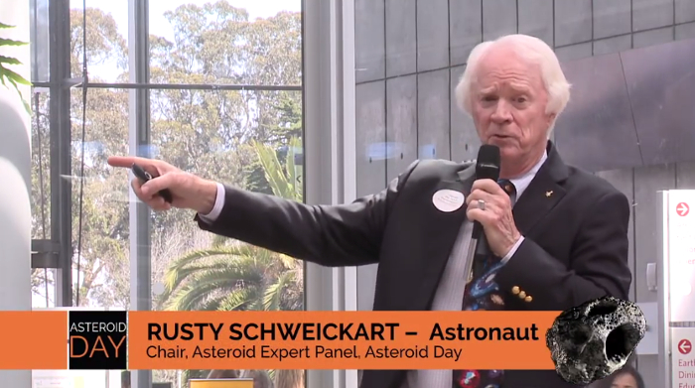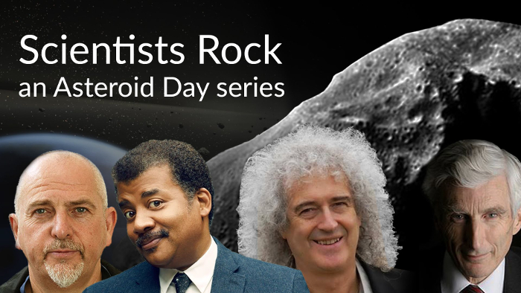

About Asteroid Day:
Asteroid Day was co-founded in 2014, by Dr. Brian May, astrophysicist and lead guitarist for the rock band QUEEN, Danica Remy, B612 President, Apollo astronaut Rusty Schweickart, and filmmaker Grig Richters. Asteroid Day is held on 30 June each year to mark the date of Earth’s largest asteroid impact in recorded history, the Siberia Tunguska event. In 2016, with the support and leadership of the Association of Space Explorers (ASE), the United Nations declared Asteroid Day to be a global day of education to raise awareness and promote knowledge in the general public about asteroids. Major events in past years have taken place in London, San Francisco, Washington, DC, Tanzania, Milan and Rimini, Italy, Garching, Germany, Santiago, Chile, and Rio de Janiero, Brazil, in addition to thousands of events worldwide.

Major sponsors of Asteroid Day include the Luxembourg Space Agency, B612, Broadcasting Centre Europe (BCE), OHB, SES, and Tomorrow Street, a joint venture of Vodaphone and Technoport. Asteroid Day global programs, including Asteroid Day LIVE, are programs of the Asteroid Foundation, a Luxembourg-based nonprofit organization.

Join in the Asteroid Day conversation on Social Media!
- Website: AsteroidDay.org
- Twitter: @asteroidday #AsteroidDay2019, #AsteroidDayLive;
- Facebook: www.facebook.com/AsteroidDay #AsteroidDay2019, #AsteroidDayLive
- YouTube: www.youtube.com/user/asteroidday

A Media Kit, including press releases, media alerts, quotes, photos, video, and BROLL, is available in the Asteroid Day Newsroom.

Media Contact: Diane Murphy, pr@asteroidday.org

