This quiz can be found at [https://asteroidday.org/resources/event-resources/asteroid-day-school-quiz/](https://asteroidday.org/?p=56413&preview=true)

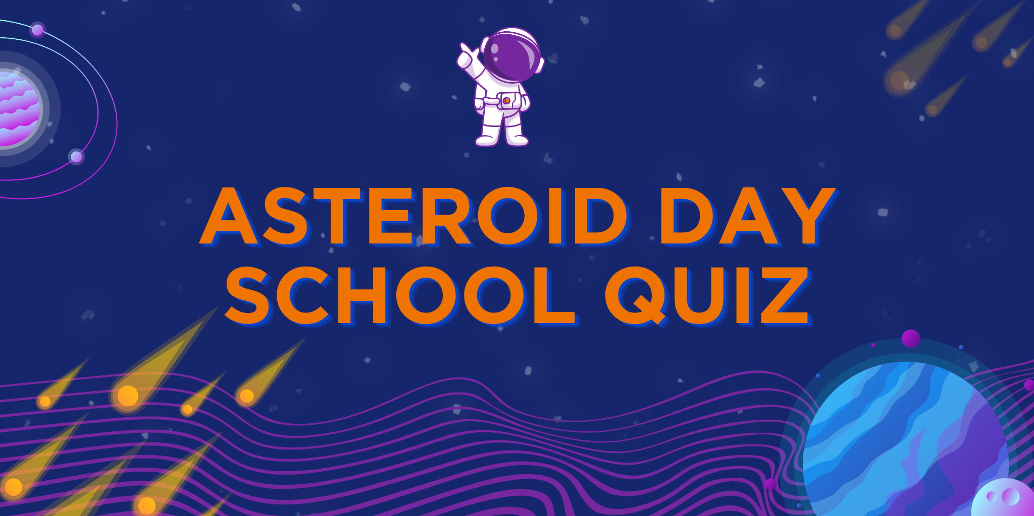

Dear Friends,

Are you ready to learn about asteroids? Asteroids are small rocky objects that orbit around the sun just like planets.

Why is it important to learn about asteroids? Well, sometimes they can come too close to Earth and if they hit our planet, it can cause a lot of damage. That's why scientists study asteroids to learn more about them and how to protect Earth from any potential impact.

So, to celebrate Asteroid Day, we've prepared a fun quiz to test your knowledge about asteroids. Ready to blast off and learn more about these fascinating space rocks? Take your pen or pencil and let's get started!

**Read this text carefully. It will help you complete the quiz tasks that follow.**☄️

Welcome, space adventurers! Have you ever heard of ASTEROIDS? They're like little space objects made of rock and metal, and they can be as small as your foot or as big as a whole planet! Celestial bodies with a diameter of less than one meter are often called meteoroids.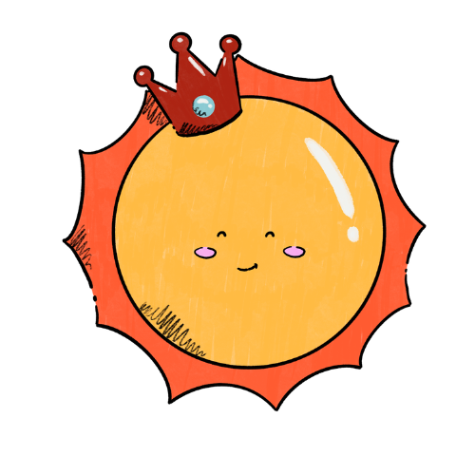

But most of them are shaped like POTATOES, not round like planets because they don't have enough gravity to make them round.

Did you know that asteroids move around just like planets? They spin around on an axis, while they also move around the sun in an orbit (it’s called TRANSLATION). This makes day and night, and even years, just like on Earth!

Most asteroids are found between the planets MARS and JUPITER, but you can also find them near other planets, including EARTH. Asteroids are actually some of the oldest things in the whole SOLAR system, leftovers from when the planets were first born billions of years ago!

The first asteroid ever discovered was called CERES, and it's still the biggest one we know of. It's almost 1,000 kilometres wide, but it's still way smaller than even the tiniest planet, Mercury. Furthermore, even though it's shaped like a potato, it's actually been classified as a DWARF planet because it's big enough to have gravity that makes it round.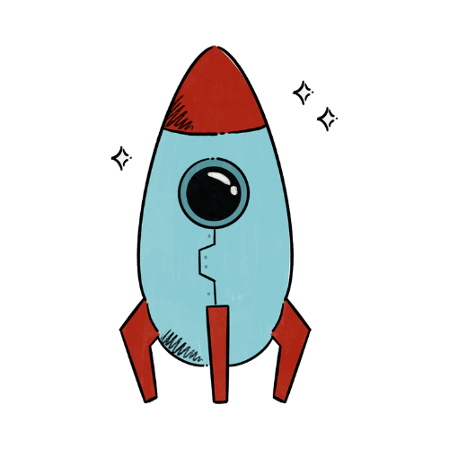

Asteroids are really interesting to study because they can tell us so much about the history of the solar system. We've even sent spaceships to visit some of them and learn even more! We've found out that some asteroids have MOUNTAINS, CRATERS, and even their own little MOONS! Can you believe that? There are over a million known asteroids out there, and who knows what we might discover next!

**Now, answer the questions to check your knowledge.**

1. Which of the following best describes asteroids?
   1. Celestial bodies made of gas and dust
   2. Celestial bodies made of rock and metal
   3. Celestial bodies made of ice and rock
   4. Celestial bodies made of liquid and gas
2. Why are most asteroids shaped like potatoes and not round like planets?
3. How do asteroids move around the sun?
4. Which of the following is true about the location of most asteroids in our solar system?
   1. They are found near the planet Saturn
   2. They are found near the planet Uranus
   3. They are found between the planets Mars and Jupiter
   4. They are found near the planet Neptune
5. What are asteroids leftovers from?
6. How big is Ceres, the biggest known asteroid?
7. What have we discovered about some asteroids through space missions?

**Word Search**

Have you noticed that the text on page 1 has CAPITILISED words? It’s not by mistake. Look for them (e.g. ASTEROIDS, POTATOES, etc) in the picture below. Found? Awesome, you can circle them!

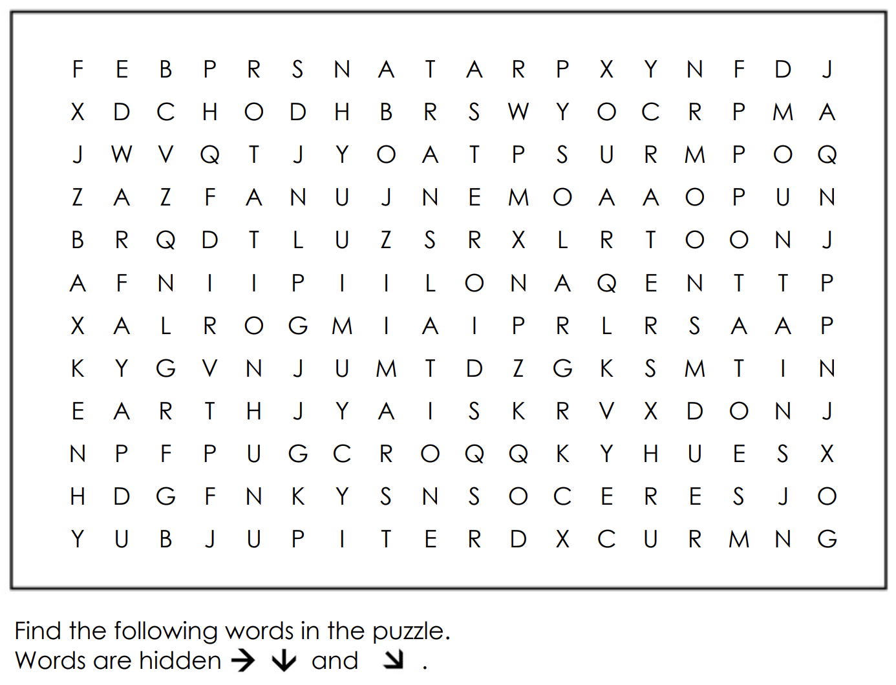

**Draw and name your own asteroid**

Imagine you have discovered an asteroid. Use the leftover space on this page and your imagination to sketch it and give it a name. Done? Go to the next page for the final quiz task.

**Crossword**

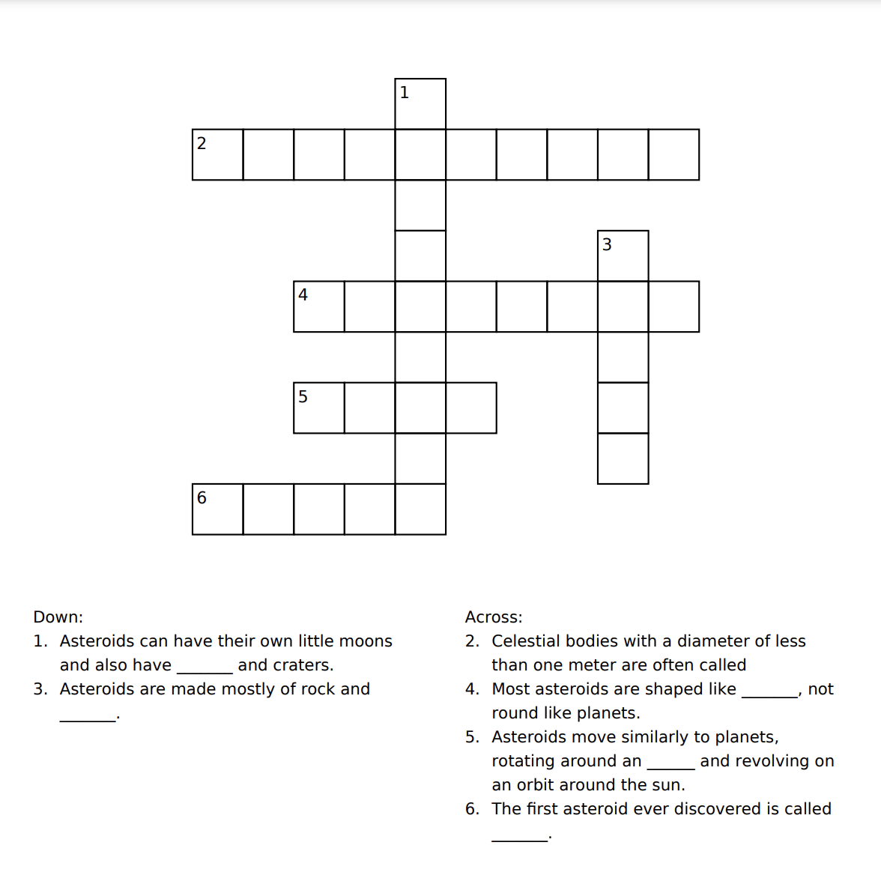

And… that’s it! 😉

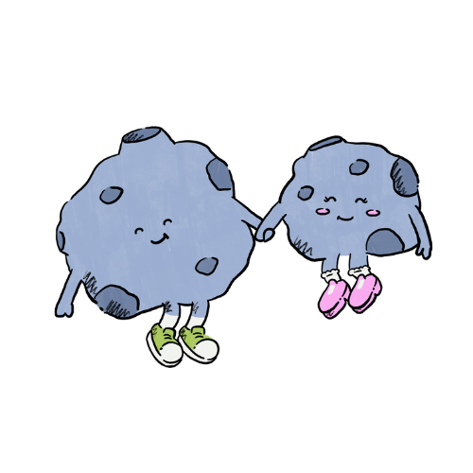

Great job on completing the asteroid knowledge quiz! You nailed it!

Asteroid Day Team just wanted to say thank you for taking the time to learn more about space and asteroids.

It's really cool to see young people like you showing an interest in science and astronomy. Your hard work and dedication are paying off!

Keep exploring and learning more about the universe. Who knows where your curiosity might take you in the future?